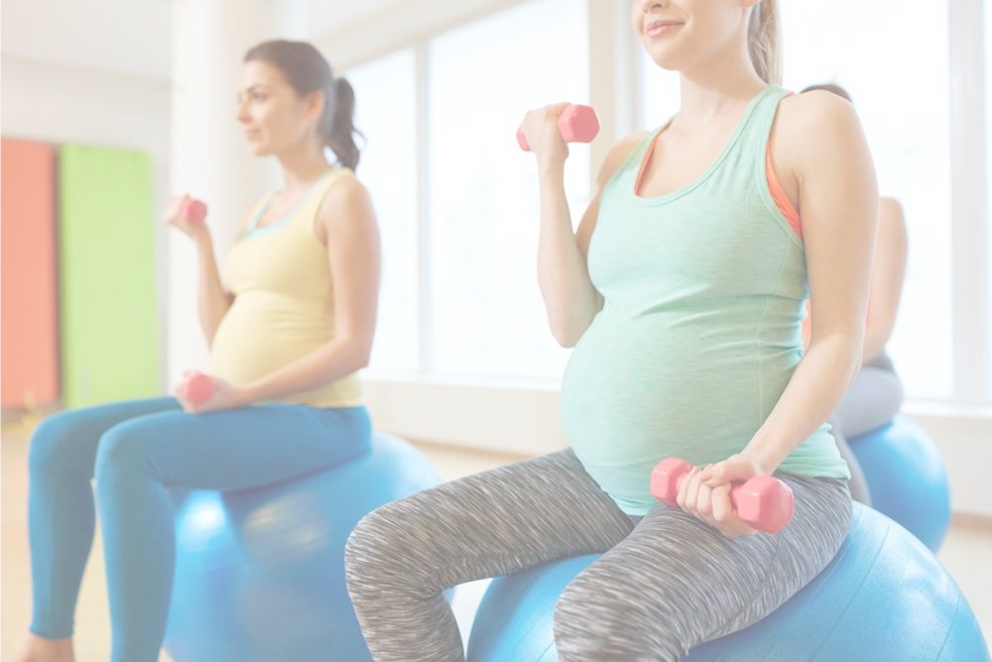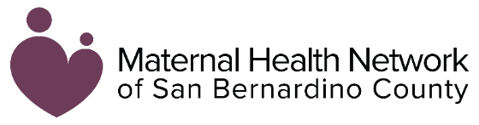**`**

**Foods**

*Some foods increase your risk of bacterial infection that can harm your baby’s development.*

*Foods to avoid include:*

* *Unpasteurized foods (soft cheeses, Queso Fresco)*
* *Seafoods high in mercury*
* *Raw, undercooked seafood*
* *Undercooked meat, poultry, and eggs*
* *Unwashed fruits and vegetables*

**2**

**1**

**3**

**Physical Activities**

*It is important to remain physically active while pregnant, but there are a few activities you should avoid.*

*Activities to avoid:*

* *Too much bed rest*
* *Lifting heavy objects (over 50 pounds)*
* *Activities with high risk of falling*

**Substances**

*Consuming certain substances while pregnant can harm both you and your baby.*

*Substances to avoid include:*

* *Smoking & Vaping*
* *Alcohol*
* *Marijuana*
* *Illicit drugs like heroin & methamphetamine*

This information is made available in part by support from the Maternal Health Network (MHN) of San Bernardino County in partnership with **[insert partner name]**. Published in 2021.

To learn more about the MHN, please visit our website at [www.maternalhealthnetworksb.com](http://www.maternalhealthnetworksb.com).

**INSERT PARTNER LOGO**

**Things to Avoid During and After Pregnancy**

**3**

**Presented by [name], [organization]**

Insert two sentence biography of subject matter expert.