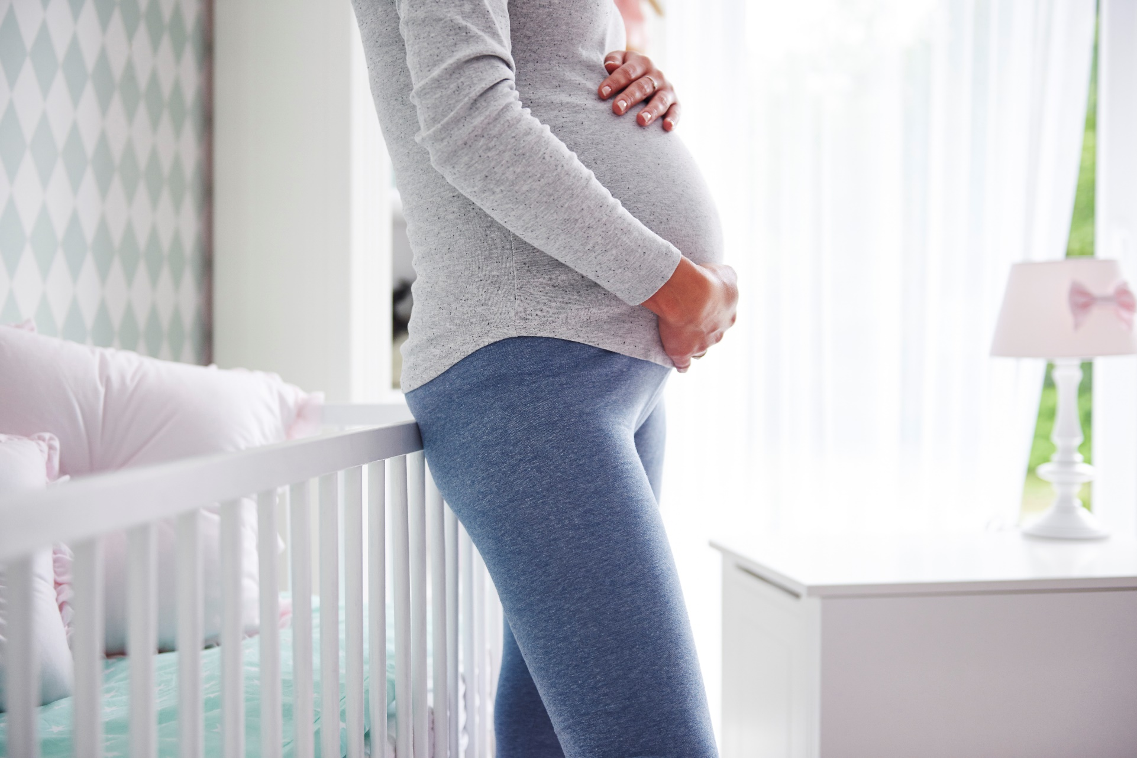

**Preparation for Conception, Pregnancy and Delivery**

*If you or someone you know would like support with or more information about preparation for conception, pregnancy, and delivery, please call* ***[insert resource name & contact information].***

**[Insert Date and Time]**

Please join us to learn a little bit about preparing for conception, pregnancy, and delivery. The gathering will provide useful information and an opportunity to discuss the following topics with [insert audience]:

* What to do when trying to get pregnant
* How to take care of your self when you are pregnant
* Steps to take to prepare for childbirth

**Presented by [name], [organization]**

Insert two sentence biography of subject matter expert.

This information is made available in part by support from the Maternal Health Network of San Bernardino County.

Published in 2022. To learn more about the MHN, please visit our website at [www.maternalhealthnetworksb.com](http://www.maternalhealthnetworksb.com).

**Insert Logo and/or Picture of Presenter**