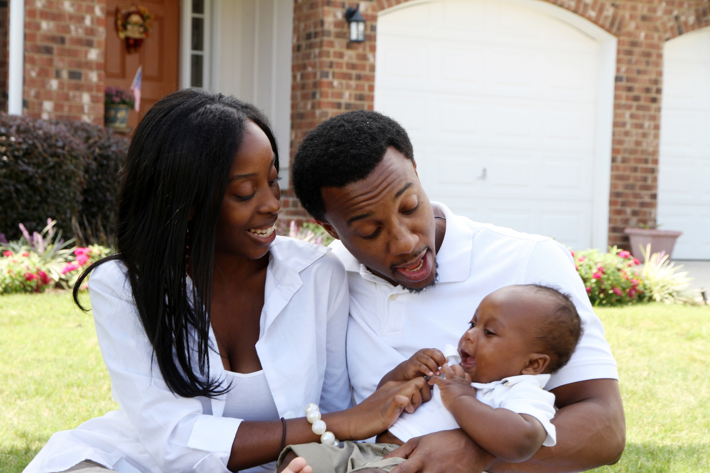****

**[Insert Date and Time]**

Please join us to learn a little bit about how to prepare a safe home for a new baby. The gathering will provide useful information and an opportunity to discuss the following topics with soon to be parents:

* Making a plan to prepare your home
* Emotionally preparing for this change
* Identifying and accessing your support system

**Preparing a Safe Home for Baby**

*If you or someone you know would like support with preparing your home prior to delivery, please call* ***211*** *or the* ***LIFT Home Visiting Program*** *at* ***909-388-0445****.*

**Presented by [name], [organization]**

Insert two sentence biography of subject matter expert.

This information is made available in part by support from the Maternal Health Network of San Bernardino County.

Published in 2021. To learn more about the MHN, please visit our website at [www.maternalhealthnetworksb.com](http://www.maternalhealthnetworksb.com).

**Insert Logo and/or Picture of Presenter**